# HEART DISEASE DIAGNOSTIC-ANALYSIS

DETAILED PROJECT REPORT

**Murala Divyasree**

# PROJECT DETAIL

|  |  |
| --- | --- |
| ***Project Title*** | Heart Disease Diagnostic – Analysis |
| ***Technology*** | Business Intelligence |
| ***Domain*** | Healthcare |
| ***Project Difficulty level*** | Advanced |
| ***Programming Language Used*** | Python |
| ***Tools Used*** | Jupyter Notebook, MS-Excel, Tableau |

**OBJECTIVE**

The goal of this project is to analyse the heart disease occurrence, based on a combination of features that describes the heart disease.

## PROBLEM STATEMENT

Health is real wealth in the pandemic time we all realized the brute effects of covid-19 on all irrespective of any status. You are required to analyse this health and medical data for better future preparation.

A dataset is formed by taking into consideration some of the information of 303 individuals.

# ARCHITECTURE

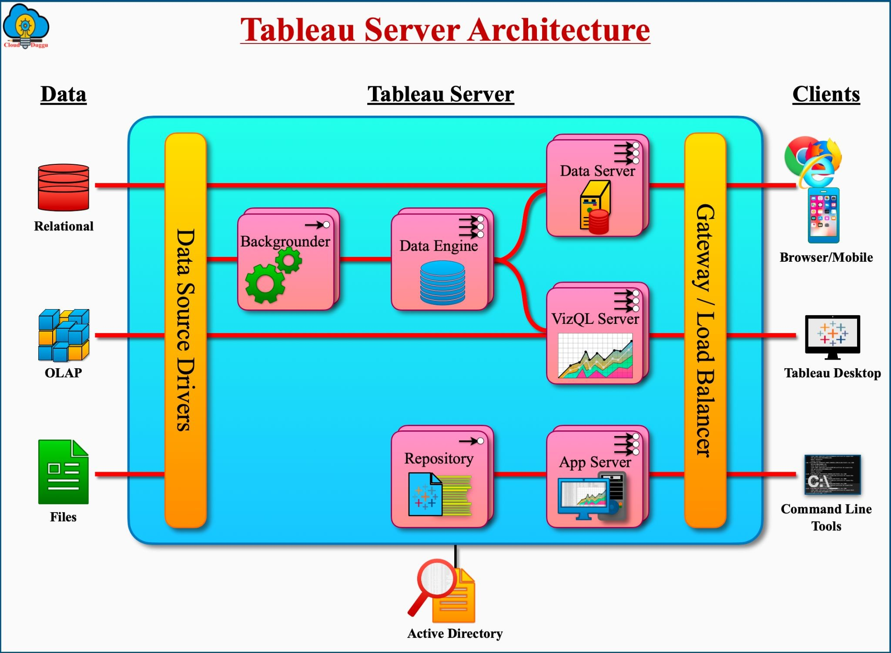

**INSIGHTS**

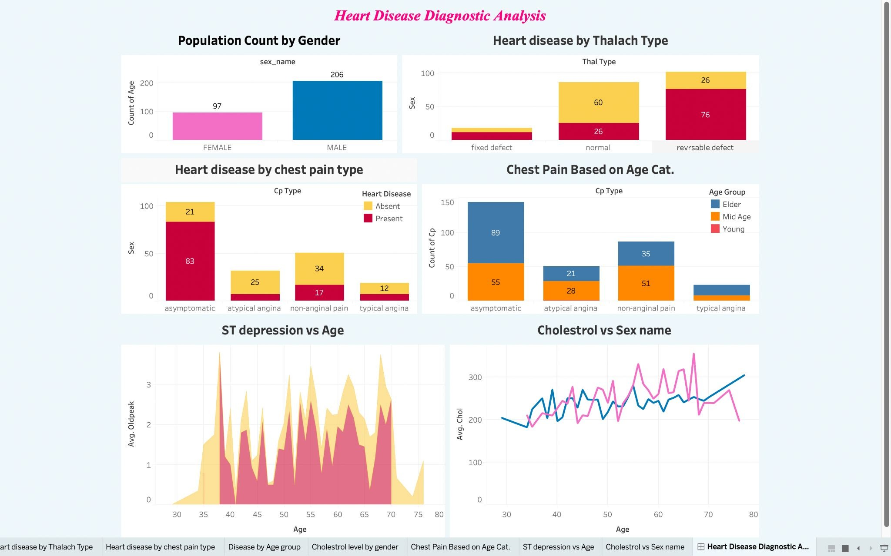

## Benefits:

* The data analysis will reveal some common and unique patterns in the dataset related to the medical parameters.
* Data visualizations will enhance the understanding of the effect of the high or low of these features on the chances of heart rate and give a better chance of prediction

# STEPS FOLLOWED

* 1. **Data Extraction**: This step involves extracting the data from different sources relevant to the problem statement or obtaining data from the client.
  2. **Data Pre-processing**: Once the raw data is obtained, we need to ensure that the data is free from errors. We perform Exploratory Data Analysis followed by Data Cleaning which involves imputing missing values, removing duplicates, finding anomalies or outliers, and treating them.
  3. **Data Exporting**: The preprocessed data is exported to a .csv file to be used for analysis.
  4. **Data Loading and Modification**: The preprocessed data in the .csv file is loaded into the Tableau Desktop for analysis purposes and modified for simplicity purposes.
  5. **Data Analysis**: Once the data is loaded, we perform the data analysis using Tableau featisualizations in Ta

**THANK YOU!**